Spaghetti Painting
Paint isn’t just for brushes, and noodles are no exception. You can make all kinds of fun art using food with your paints Watch out, the noodles get a bit slippery when covered in paint!
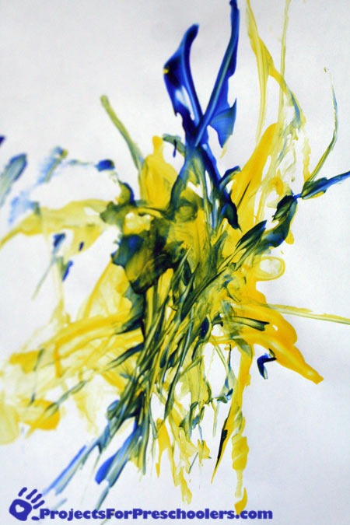Spaghetti painting art
Spaghetti painting can get a little messy, so plan ahead and make sure to cover the work area. children should wear a paint shirt to prevent any paint getting on their clothes. You can swirl the noodles around on the paper, use the noodle in a whip motion to splatter paint or add a whole bunch of noodles at once. Have fun exploring what noodle painting can do!
To make a spaghetti painting you’ll need:
- Cooked and cooled noodles
- Finger paint
- Paper
- Paint shirt and paint mat

SALT PAINTING
You could use any shapes you like for your salt and watercolor painting. We have gone with simple star shapes! Kids could also write their names with the glue and salt, or make other patterns and pictures.
Stiff paper is recommended for your raised salt painting instead of computer paper or construction paper.
You can also use watercolors instead of our simple food coloring and water mixture below!

YOU WILL NEED:
- PVA school glue or craft glue
- Salt
- Food coloring (any color of choice)
- Water
- White card-stock or watercolor paper
- Template for your shapes

HOW TO MAKE SALT PAINTING
You may want to do this activity in two stages to allow the salt and glue to dry before adding watercolor.
STEP 1: Trace your template onto cardstock.
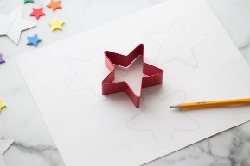
STEP 2: Add glue to outline your shapes.
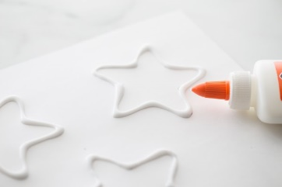
STEP 3: Then add a good amount of salt onto the glue and carefully pour the excess salt off.
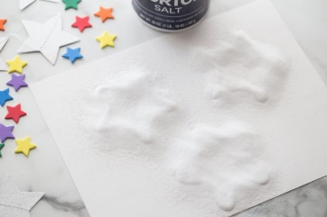
STEP 4: Let the glue and salt dry.

STEP 5: Mix a few tablespoons of water with your choice of food coloring to make your watercolor paint.
Salt Painting Tip: The more food coloring you use the darker your “paint” will appear.

STEP 6: slowly drip the watercolor mixture onto the salt. Try not to drench the patterns but rather watch the salt soak up one droplet of color at a time.

