**Learn**

**Play**

**Hello**

**Write**

**Friends**

**Jets Nursery**

**Language Pack**

**Read**

**Thrive**

**Goodbye**

**Communication**

**Grow**

Dear Parents/Carers,

Jet’s Nursery have done lots of training for Language development and have lots of different tools to help us support children with communication and Language difficulties. Jet’s would like to share some of this information with our parents/carers, so they can continue to support their children at home with the same tools and strategies used in Nursery. We realise that parents/carers are their child’s main caregiver/educators and without your support and partnership, our children will not learn, thrive and grow to their full potential.

Within this pack, you will find lots of information to support, encourage and develop language and communication. You will have strategies to use at home, top tips, the stages of language development, brain development, the communication and language development area of learning and useful website to enable you to assess more information.

We hope you enjoy looking through this pack and if you have any questions or comments, please do not hesitate to ask a member of the Jets Nursery Team, who will do their best to help or find out the information you want.

Thank you

Jet’s Nursery

Strategies to Support Communication and Language Development

**Use gestures or actions to support the spoken words**

**Comment on things your child is doing instead of asking questions**

Comment Instead of Questioning

**Name what things are called and used for during everyday situations**

**Talk about what you are doing during play or daily routines**

**Add one or two words on to your child’s words or sentences**

**Offer your child a choice of two words e.g milk or juice**

Model

**Use simple language for your child to understand**

**Provide opportunities to communicate with your child**

**10 second rule. Allow your child some thinking time to reply**

**Do not tell your child they are wrong, simply repeat the correct word/sentence back to them**

Stop, Listen and Respond

**Acknowledge with words, what your child says or does e.g they point or gesture you name the object/toy etc**

**Show anticipation while waiting for your child to respond**

**Join in their play or singing and copy what they are doing**

**Get down to your child’s level**

**Speak about the here and now**

**Slow down, do not be scared of the silences**

Follow the Child’s Lead

**Top Tips**

Here are some top tips to support communication and language development and explain some of the strategies in more detail:

* When talking to your child, be sure to reduce the noises that will distract them from listening to you, for example, turn off the TV, tablet or music.
* Make it easier for them to talk, dummies can get in the way. Try to keep them just for sleep times.
* Asking lots of questions can make your child feel tested, instead comment on what they are doing or what is happening and only ask genuine questions.
* Add on one or two words to your child’s sentence to build up their vocabulary for example, if they say ‘bus’ you say ‘yes, big bus’.
* Read and tell stories to your child. It is never too early to start sharing stories with your child. Start with simple board books and build up to picture and story books as your child grows. Making up stories also allows your child to use their imagination, making characters, scenes and adventures.
* Enjoy music with your child. Children love to learn and join in with movement and music and it is a great way for your child to learn about the world around them and the rhythm of language.
* Never tell your child they are pronouncing words wrong, this will knock their confidence and might reduce their language and communication development. Instead, repeat the correct word or sentence back to them, emphasising the mistaken word and give them lots of praise and encouragement.
* Finally, Talk, talk, talk to your child! At every opportunity talk about what you are doing, what is happening around them and what they are seeing. Children have to hear words several times before they can use them in context, so the more you talk to your child, the more they will learn and be able to communicate.

**Language Pyramid**

There are stages of development all children must go through, to be able to communicate with their family, friends and colleagues. If one of these stages of development are missing, children will find it difficult to reach the top of the pyramid.

**Speech sound development**

**Verbal conversations**

**Simple conversations**

**Understanding and using phrases and sentences**

**Using single words**

**Verbal Understanding**

**Pointing**

**Gesture**

**Situational Understanding**

**Vocalisation**

**Babble**

**Turn-taking**

**Hearing**

**Looking**

**Attention**

**Listening**

**Brain Development**

New experiences and repeated refrains allow the brain to develop connections within the first two years. A two-year olds brain has twice as many synapses as an adult brain! Pruning begins after this and the brain selects which information is needed and which is not, depending on how much the brain is stimulated. (If you don’t use them, you will lose them!). This means it is especially important to provide as many different opportunities and experiences, so your child can make lots of connections and start to understand, learn and grow with the world around them.

Here is a picture of how many synapses are in a child’s brain and how they develop over the years. When a child reaches four years old, their brain will start to prune itself, keeping the connections and information that is frequently stimulated and removing what is not being stimulated.

[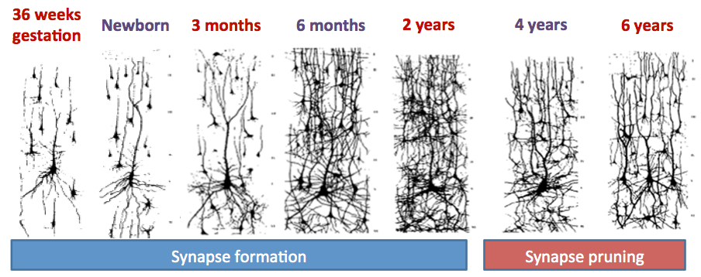](http://www.google.co.uk/url?sa=i&rct=j&q=&esrc=s&source=images&cd=&cad=rja&uact=8&ved=0CAcQjRw&url=http://grahamscharf.com/infographics/&ei=RZBkVcXbGIWmU_zbgugD&psig=AFQjCNFG-vflqjn-i1rkGYtPt0iSfsI06Q&ust=1432740063276430)

Communication and Language Area of Learning

Here is the communication and language area of learning that we must observe, evidence and plan for during your child’s time at Jet’s. Please do not worry if your child is not meeting any milestones within these areas, all children are individuals and develop at different rates. Once we assess this, there are things we can put in place to support and develop these areas. If you are worried about your child’s Speech and Language, please speak to a member of our staff team.

**Useful Websites**

Here are some websites which will give you more information on communication and language development. The site will have ages and stages of language development, nursery rhymes, facts, tips and advice.

[www.wordsforlife.org.uk](http://www.wordsforlife.org.uk)

[www.talkingpoint.org.uk](http://www.talkingpoint.org.uk)

[www.thecommunicationtrust.org.uk](http://www.thecommunicationtrust.org.uk)

[www.earlyyearsmatters.co.uk/communication-and-language-matters/](http://www.earlyyearsmatters.co.uk/communication-and-language-matters/)

<https://www.nurseryworld.co.uk/>

<http://www.ican.org.uk/>

<http://www.parents.com/>

<https://pathways.org/topics-of-development/milestones/>

<https://childdevelopmentinfo.com/child-development/language_development/>